1. Questions to be resolved with IBM 1
2. Problems with DB2 General Admin Tools 1
3. Problems with Data Studio 2.2 1
4. Problems with Data Architect 2
5. Problems with Mashup Center 3
6. Problems Logging in to DB2 in the Clouds – August 2nd. 4
7. Problems Logging with my IBM ID – August 2nd. 5

1. Questions to be resolved with IBM
- How do I load CSV data into a DB2 Table ?
- How do I run SQL Scripts using IBM Data Studio ?

2. Problems with DB2 General Admin Tools
I have installed DB2 and Data Studio 2.2 but have encountered the problems listed below.
- What do I do about these problems with DB2 General Admin Tools ?
  - “No start database command executed”
  - “Serve Communication Error”

3. Problems with Data Studio 2.2
Problems with IBM Data Studio 2.2 are shown in this Screenshot –
- No links are clickable and there is an image missing on the bottom right :-

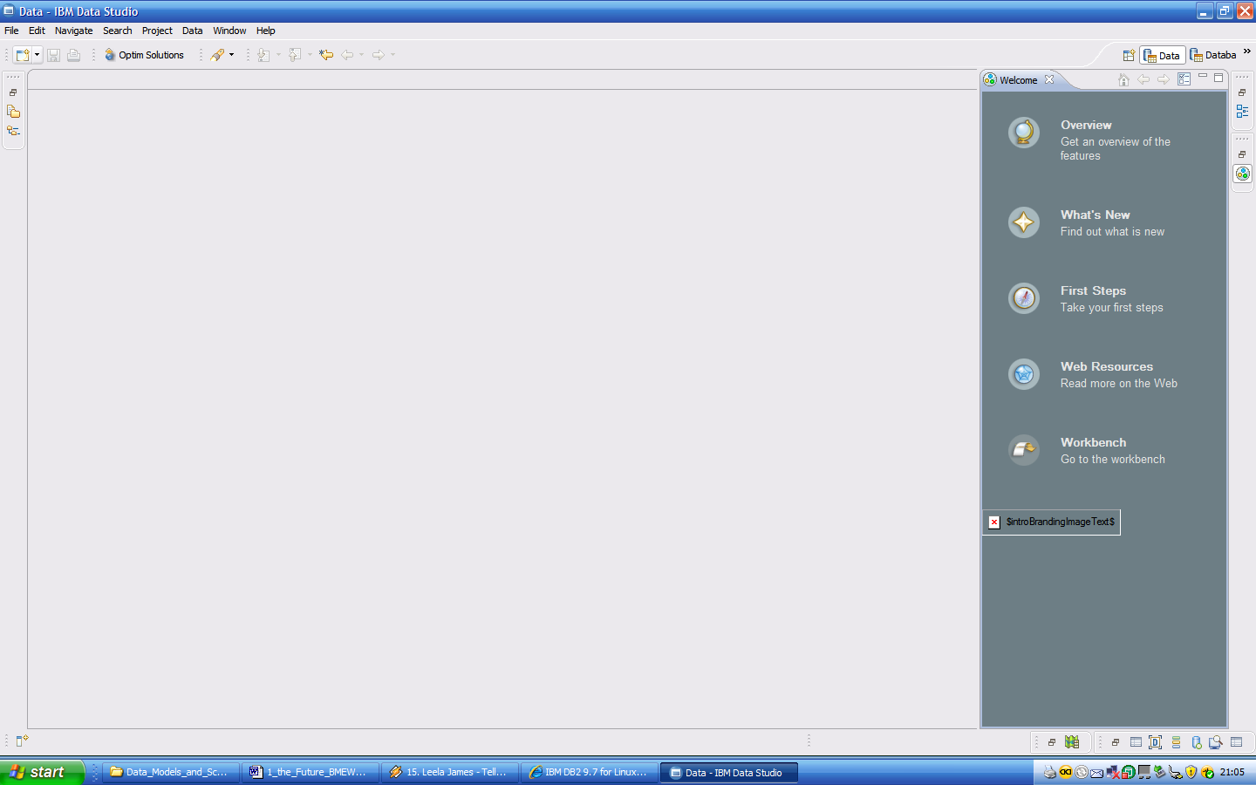

4. Problems with Data Architect
Trying to install Data Architect produces this error message –

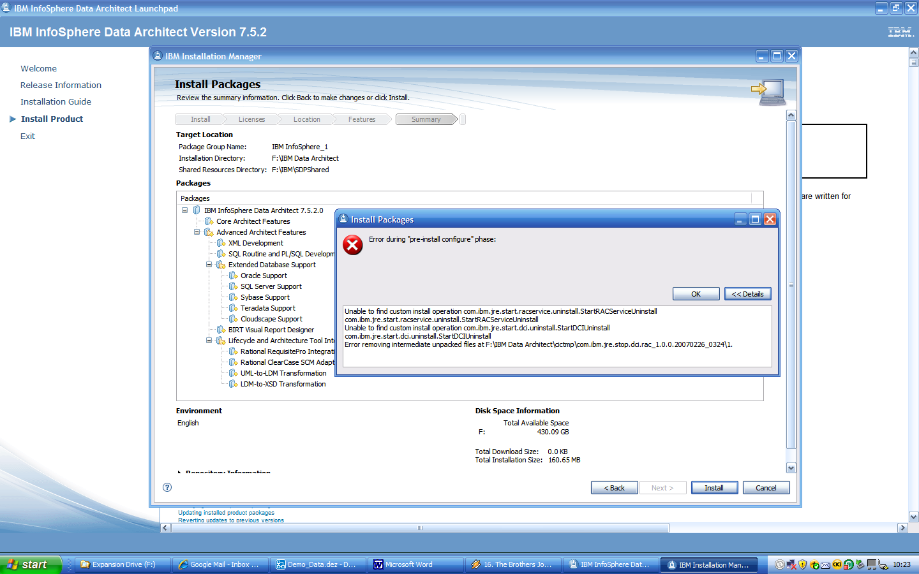

5. Problems with Mashup Center
Clicking on ‘Start Server’ produces this error message –

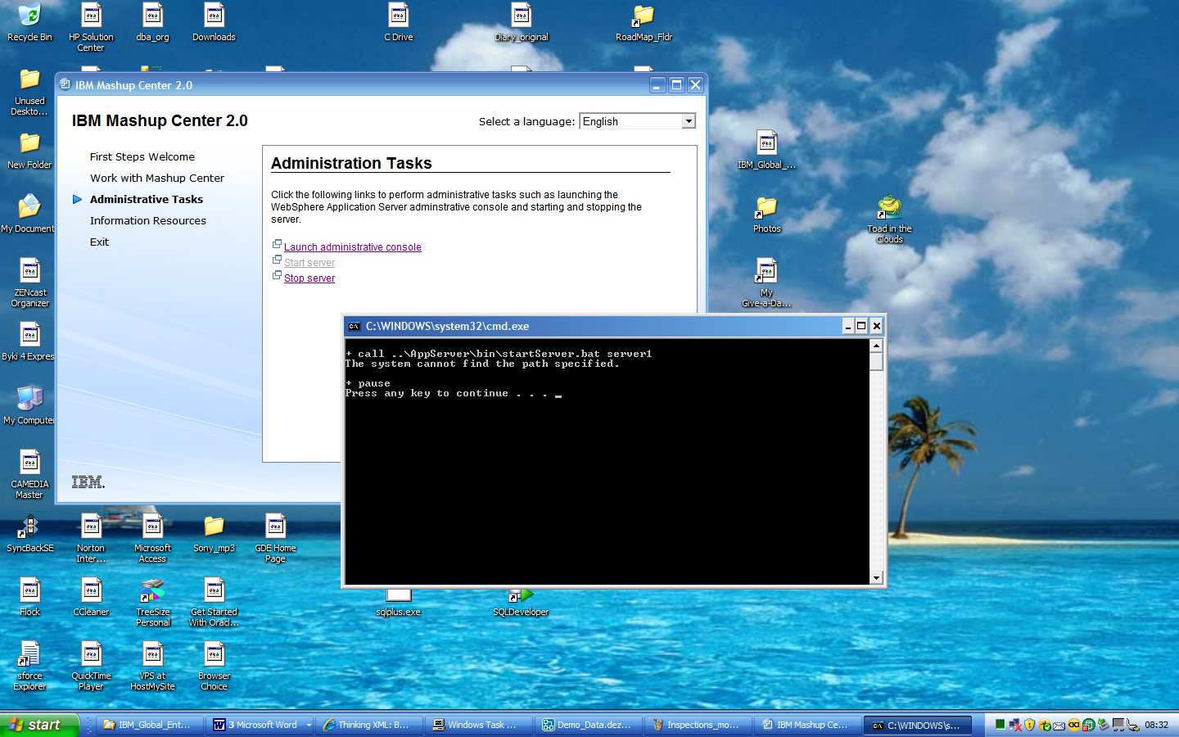

6. Problems Logging in to DB2 in the Clouds – August 2nd.
Even though II have been signed up as a Business Partner for over a year, and I am now in the IBM Global Entrepreneur Program, it seems I
cannot login to DB2 in the Clouds - https://www-147.ibm.com/cloud/enterprise/dashboard

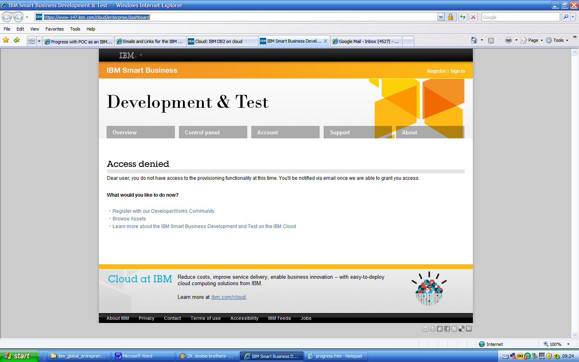

7. Problems Logging with my IBM ID – August 2nd.
Now I can’t login to register for a Developers Cloud Event.

